The top 3D-printed Raspberry Pi cases
If you are looking for the best 3D-printed Raspberry Pi cases, then you have come to the right place. In this article, we will be discussing the top 10 3D-printed Raspberry Pi cases that are available in the market.

We all know that the Raspberry Pi is a credit-card-sized computer that can be used for various purposes. It is a powerful little device that has the ability to perform many tasks. The best thing about the Raspberry Pi is that it is very affordable and can be used by anyone. There are many different types of 3D-printed Raspberry Pi cases available in the market

The top 10 3D-printed Raspberry Pi cases are all interesting and unique in their own way. Here is a list of the top 10 cases:

1. The Adafruit 3D-printed case
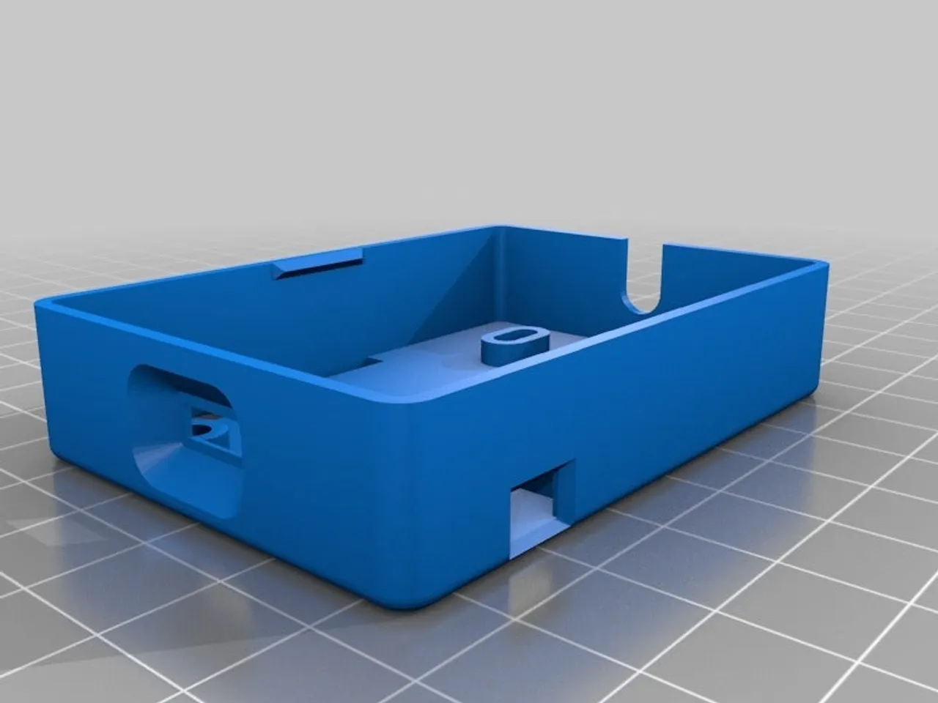
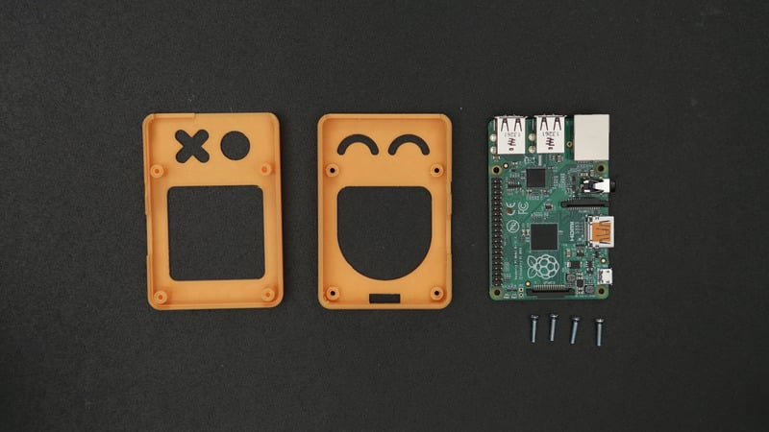

The Adafruit 3D printed case is a 3D printed case designed specifically for the Adafruit PyPortal Internet of Things display. The case is designed to protect the display from damage and to provide a stylish look. The case is made from high-quality PLA plastic and is available in a variety of colors.

Adafruit's 3D-printed cases are designed to protect your Raspberry Pi while providing easy access to the GPIO pins. The cases are made of two parts: a top and a bottom. The top is made of clear acrylic, while the bottom is made of black ABS plastic. The two parts are held together with screws, and the GPIO pins are accessible through a hole in the bottom. The Adafruit 3D printed case is a great way to protect your Raspberry Pi.

2. The Flirc 3D printed case
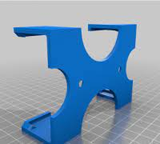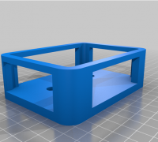
The case is designed to protect your Raspberry Pi from damage and keep it looking good. The case is made from high-quality materials and is easy to assemble. The case is also very easy to use and is compatible with all Raspberry Pi models.

The Flirc 3D printed case can benefit you by providing a custom-fit case for your device. This can help to protect your device from bumps and scratches, and can also improve its overall look. Additionally, the Flirc 3D printed case can help to improve the grip of your device, making it more comfortable to hold.

The Flirc 3D printed case is a great way to add a personal touch to your Flirc remote. You can customize the case to match your personal style, or to match the look of your living room. There are a few things to keep in mind when customizing your case, however.

First, you'll need to choose a design that fits your Flirc remote. Second, you'll need to select the right material for your case. And finally, you'll need to choose the right color for your case. It is the best choice for you because it is made from high-quality materials and it is designed to protect your Flirc remote from damage. The case is also very stylish and it will look great in your home.

3. The Pibow 3D-printed case
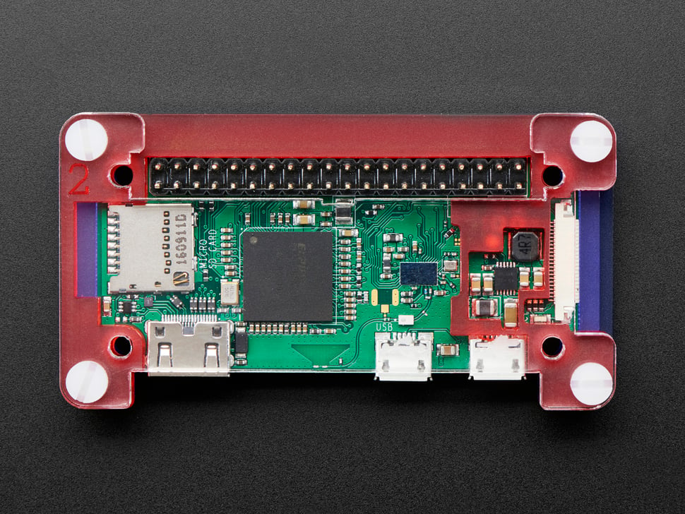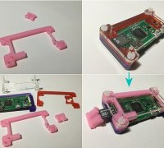
The Pibow is a new and improved way to protect your Raspberry Pi. It is made out of 3D printed material which makes it more durable and long-lasting than the traditional plastic cases. The Pibow also has a better fit and finish than the older cases and looks much more stylish.

The Pibow 3D printed case is designed to protect your Raspberry Pi Zero W. It is made of six layers of 3D printed material, which are sandwiched together to form a strong and durable case. The case has a hole in the top for the GPIO header, so you can access the pins without taking the case off. The case also has a hole for the camera module, so you can take pictures and videos with your Pi Zero W.

The case is easy to assemble, and it comes with all the necessary screws and nuts. This means that you won't have to spend a lot of time putting it together. The Pibow 3D printed case is a great way to protect your Raspberry Pi. It is also very affordable, making it a great option for anyone looking for a case for their Raspberry Pi.

4. The Pimoroni 3D-printed case
This case is a great option if you're looking for something that's easy to assemble. The Pimoroni 3D printed case comes with everything you need to get started, and the instructions are clear and concise. The only tools you'll need are a screwdriver and a pair of pliers. The case is also very lightweight, making it easy to transport.

If you're looking for a 3D-printed case for your Raspberry Pi, Pimoroni has a great selection that's sure to fit your needs. Their cases come in a variety of colors and styles, and they even have a clear case that lets you show off your Pi's innards. They also have a case that's designed to be used with their own pHATs (Printed-circuit board on top of the Pi). So whether you're looking for a simple case to protect your Pi, or something a little more flashy, Pimoroni has you covered.

5. The ProPi 3D-printed case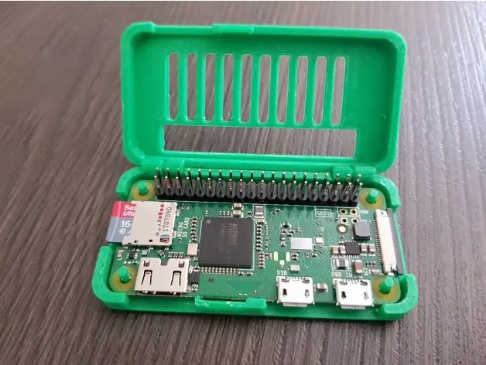

3D printing technology has come a long way in recent years, and there are now a variety of different types of ProPi 3D printed cases available on the market. Depending on your needs, you can choose from a variety of different materials, sizes, and shapes.

The most common type of ProPi 3D printed case is made from plastic. Plastic cases are typically the most affordable option, and they come in a wide variety of colors and styles. If you're looking for a basic, no-frills case, a plastic ProPi case is probably your best bet.

If you need a more durable case, you might want to consider a metal ProPi case. Metal cases are typically more expensive than plastic cases, but they're also much more durable. If you're looking for a case that will stand up to heavy use, a metal ProPi case is a good option.

If you're looking for a ProPi case that's both durable and stylish, you might want to consider a wood ProPi case. Wood cases are typically more expensive than plastic or metal cases, but they offer a unique look that you won't find with other types of cases.

ProPi 3D printed cases are becoming increasingly popular due to their many advantages over other types of cases. Perhaps the most obvious advantage is that they can be customized to fit any size or shape of the device, making them ideal for use with a wide variety of devices. Additionally, ProPi cases are very lightweight and durable, making them ideal for use in a wide variety of environments. Finally, ProPi cases are very easy to install and remove, making them perfect for those who need to access their device frequently.

6. The SmartiPi Touch case
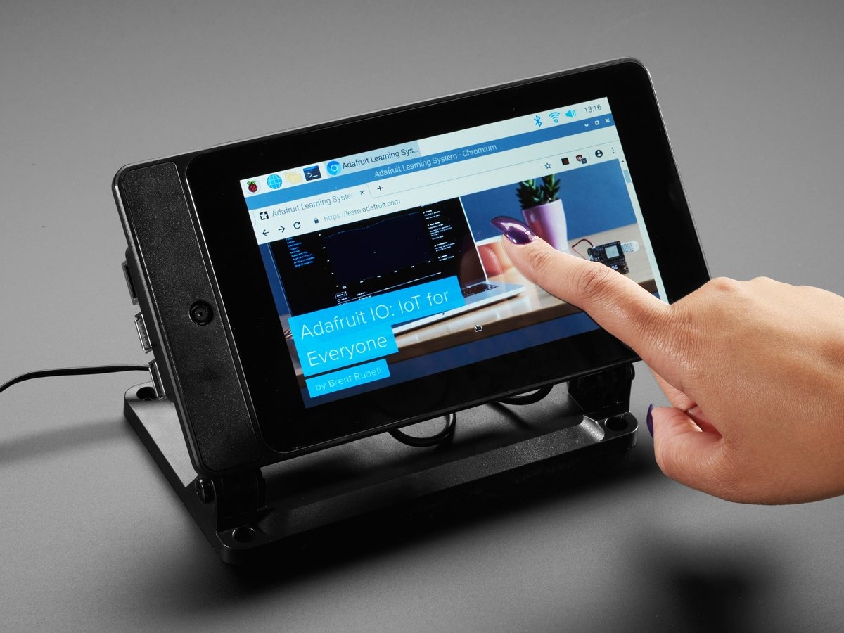
The SmartiPi Touch case is a great way to protect your Raspberry Pi touchscreen display. The case is made of durable ABS plastic and has a clear acrylic front panel that allows you to see your display. The case also has a mounting point for the official Raspberry Pi camera module, so you can add a camera to your setup. The case comes with all the necessary hardware to mount your Raspberry Pi touchscreen display and camera module.

There are a few drawbacks to consider before buying one. First, the case is made of plastic, so it's not as durable as some of the other cases on the market. Second, the case doesn't have a lot of ventilation, so your Raspberry Pi can overheat if you're not careful. Finally, the case is a bit on the expensive side, but it's worth it for the protection it provides.
Overall, the SmartiPi Touch case is a great way to protect your investment and keep your Raspberry Pi looking new. The case is well-made, and the included stand is a nice addition. If you're looking for a way to keep your Pi safe and sound, the SmartiPi Touch case is a great option.

7. The Vilros 3D-printed case
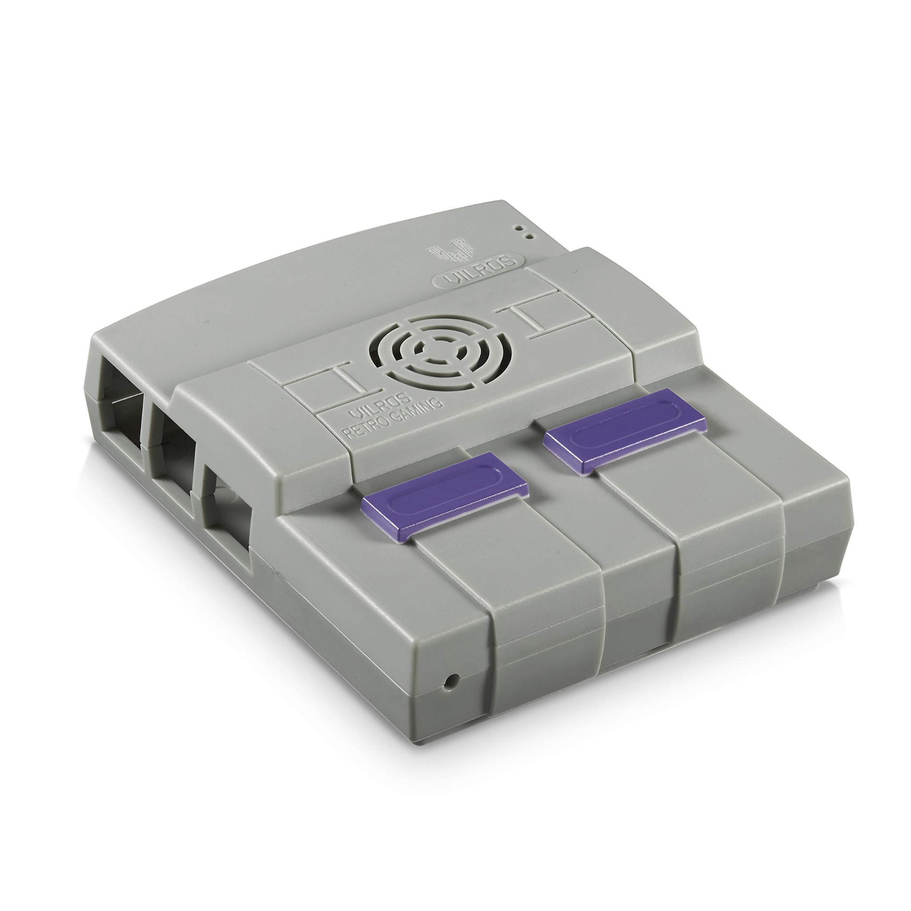
The Vilros 3D printed case is a great way to protect your Raspberry Pi. The case is made of high-quality ABS plastic and is designed to fit the Raspberry Pi 3 Model B+. The case has a clear top so you can see the LED lights on the Pi, and it also has a slot for the camera so you can take pictures and videos with your Pi. Vilros 3D printed cases are popular among Raspberry Pi enthusiasts for a few reasons.
The main benefit of a 3D-printed case is the protection it offers. The Pi board is a delicate piece of technology and it can be easily damaged if not properly protected. A case will safeguard your Pi from bumps, scratches, and other potential hazards.

Another benefit of a 3D-printed case is the ability to customize it to your specific needs. For example, you can add ventilation holes to keep your Pi cool, or you can add a camera mount if you plan on using the Pi for photography or video. There are literally hundreds of different case designs available, so you’re sure to find one that meets your needs.

Finally, 3D-printed cases simply look great. They add a touch of personality to your Pi and can make it stand out from the crowd. Whether you want a sleek and simple case or something more outrageous, there’s a 3D-printed case out there for you.

If you're looking for a Vilros 3D-printed case, there are a few ways to get your hands on one. You can either purchase one online from a retailer such as Amazon, or you can find a local 3D printing service that offers the case. Vilros also offers a few different 3D-printed case designs on their website, so you can choose the one that best suits your needs.

3D printing is a great way to create a custom case for your Raspberry Pi
There are many different designs available, or you can create your own. 3D printed cases can be found for a variety of different prices, depending on the design and the materials used. After looking at the different 3D-printed Raspberry Pi cases, it is clear that there are many different designs to choose from. Some are simple and functional, while others are more elaborate and decorative. No matter what your preference is, there is sure to be a 3D-printed Raspberry Pi case that will suit your needs. Each of these cases has its own unique features and benefits, but all three are designed to protect your Raspberry Pi and keep it looking great.

